1.What is the purpose of the core module in AEM?

To keep all the business logic oriented content and java code as a single unit in order to separate the backend part.

2.What kind of files and code can be found in the core folder?

It has java files related to listeners, models, servlets etc. It also has java test files.

3.Explain the role of ui.apps in AEM projects.

It is a module which contains all frontend related contents and files including css and js.

4.How are components structured in the ui.apps folder?

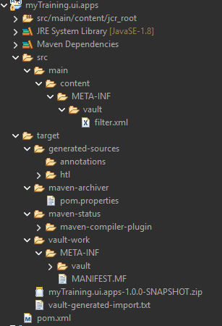

**5.Hello World Component:**

* Where is the Hello World component located in both core and ui.apps?
* 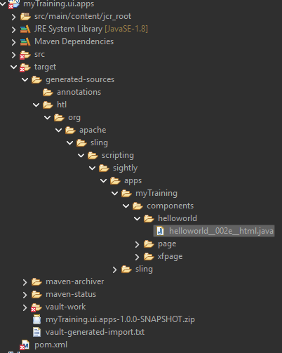

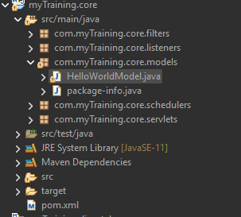

* Explain the Java class (in core) for the Hello World component.
* It holds the business logic.
* How does the HTL script work in ui.apps for Hello World?
* It defines how the "Hello World" component is rendered.
* How are properties and dialogs defined for this component?
* Using jcr:content.

6.What are the different types of AEM modules (core, ui.apps, ui.content, etc.)?

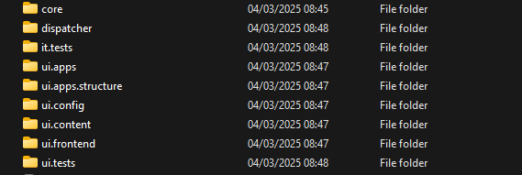

7.How does Maven build these modules?

By reading pom.xml file.

8.Explain the build lifecycle of Maven in the context of AEM.

It first validates the pom.xml file then compiles the java code followed by running the unit tests. Finally it creates the jar or zip file (package).

9.How are dependencies managed in pom.xml?

<version> tag is used to manage dependencies.

10.Why is Maven used instead of other build tools?

It is an effective build automation tool.

11.What advantages does Maven offer for AEM development?

Project Structure, Build Automation, Dependency Management.

12.How does Maven help in managing dependencies and plugins in AEM projects?

Maven helps to manage dependency versions effectively.

13.What does mvn clean install do in an AEM project?

It clears the existing target directory and build the new one.

14.How to deploy packages directly to AEM using Maven commands?

mvn clean install -PautoInstallPackage

15.Explain the purpose of different Maven profiles in AEM (autoInstallPackage, autoInstallBundle).

autoInstallBundle – is used when only changes in java codes.

autoInstallPackage – is used to deploy whole project(java code+ other contents)

16.What is the purpose of dumplibs in AEM?

It is used for diagnosing issues.

17.How can you view client libraries using dumplibs?

Enter this url: http://localhost:4502/libs/granite/ui/content/dumplibs.html.

18.Explain how client libraries are structured in AEM.

